# GURU NANAK INSTITUTE OF MANAGEMENT

(AFFILIATED TO GURU GOBIND SINGH INDRAPRASTHA UNIVERSITY)



## Multimedia Technologies– MCA 357

## PRACTICAL FILE

|  |  |
| --- | --- |
| SUBMITTED TO: | SUBMITTED BY: |
| Prof. Shubhra Saggar | CHIRAG BITONI |
| (Professor) | MCA(3rd Sem) |
|  | 01013004421 |

INDEX

|  |  |  |  |
| --- | --- | --- | --- |
| **S.NO.** | **EXPERIMENTS** | **PAGE**  **NO.** | **TEACHER’S**  **SIGNATURE** |
| **1** | **Photo Effects**  **Watercolor Painting Effect In Photoshop CS6** | **01** |  |
| **2** | **Photoshop CS6 New Features** |  |  |
|  | **2.1) Background Save** | **11** |
|  | **2.2) Auto Save** | **14** |
| **3** | **Photo Editing** |  |  |
|  | **3.1) How To Lighten And Brighten Eyes In** | **16** |
|  | **Photoshop** |  |
|  | **3.2) Changing eye color in an image in Photoshop** | **23** |
|  | **3.3) Photoshop black and white conversion- desaturating** | **29** |
| **3.1** | **The Desaturate Command** | **30** |  |
| **3.2** | **The Hue/Saturation Adjustment Layer** | **31** |  |
| **4** | **Text Effect**  **4.1) Multiple Text Strokes with smart objects in photoshop** | **35** |  |
| **5** | **Digital Photo Essentials**  **5.1) Save Photos For Email or The Web In Photoshop CS5** | **41** |  |

# Photo Effects

## Watercolor Painting Effect In Photoshop CS6 Step 1: Duplicate The Background Layer

Let’s begin by looking in our [Layers panel](http://www.photoshopessentials.com/basics/layers/layers-panel/) where we see that with our photo newly open in Photoshop, we’re starting with just a single layer – the [Background layer](http://www.photoshopessentials.com/basics/layers/background-layer/) – which holds our image:

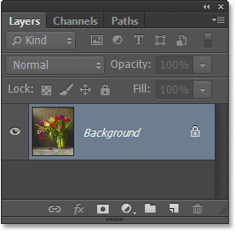

The Layers panel showing the photo on the Background layer.

We need to duplicate the layer, and we can do that by going up to the **Layer** menu in the **Menu Bar** along the top of the screen, choosing **New**, and then choosing **Layer Via Copy**. Or, we can simply press **Ctrl+J** (Win) / **Command+J** (Mac) on the keyboard to access the same command with the shortcut:

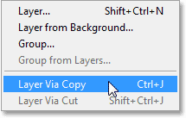

Going to Layer > New > Layer Via Copy.

And now if we look again in the Layers panel, we see a copy of the layer, which Photoshop has automatically named **Layer 1**, sitting above the original Background layer:

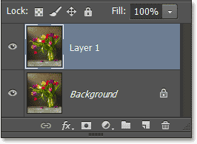

The copy of the layer appears above the original.

## Step 2: Convert The Layer Into A Smart Object

Let’s convert our new layer into a **Smart Object** so that when we apply a filter to it, as we’ll do in a moment, the filter will be applied as a **Smart Filter** which means it will remain fully editable. With Layer 1 selected in the Layers panel (it should be highlighted in blue), go back up to the **Layer** menu at the top of the screen, choose **Smart Objects**, then choose **Convert to Smart Object**:

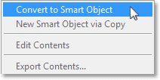

Going to Layer > Smart Objects > Convert to Smart Object.

You won’t see anything happen with the image in the document window, but a small **Smart Object icon** appears in the lower right corner of the **preview thumbnail** for Layer 1, telling us it’s now a Smart Object:

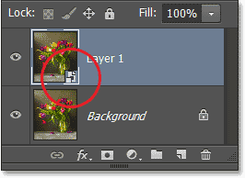

A Smart Object icon appears in the preview window.

## Step 3: Make Two Copies Of The Smart Object

We need to make a couple of copies of our Smart Object, so let’s just use the quick and handy keyboard shortcut we heard about back in Step 1. Press **Ctrl+J** (Win) / **Command+J** (Mac) to

make the first copy, then press the same keys (**Ctrl+J** (Win) / **Command+J** (Mac)) a second time to make the second copy. Both copies of the Smart Object will appear above the original in the Layers panel:

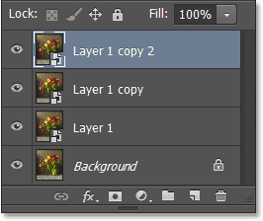

The Layers panel showing the two copies of the Smart Object above the original.

## Step 4: Rename The Layers

The default names that Photoshop has been giving our layers, like “Layer 1 copy” and “Layer 1 copy 2″, may be good enough for Photoshop but they’re certainly not very useful to us humans, so let’s quickly rename the layers to something more descriptive. To rename a layer, **double-click** directly on its name, type in the new name, then press **Enter** (Win) / **Return** (Mac) to accept it. We’ll name the layers based on the filter we’ll be applying to each one. Change the name of “Layer 1″ to **Cutout**, then rename “Layer 1 copy” above it **Dry Brush**, and finally, change “Layer 1 copy 2″ at the top to **Median**:

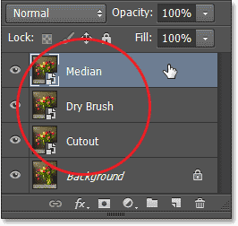

Renaming our layers.

## Step 5: Hide The Top Two Layers From View

Hide the two layers at the top (Median and Dry Brush) from view in the document window by clicking on their **layer visibility icons** (the “eyeball” icon on the far left of each layer in the Layers panel). When the visibility icon is blank (meaning there’s no eyeball inside the little square), the layer is temporarily hidden:

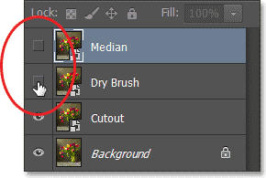

Hiding the top two layers by clicking on their visibility icons.

## Step 6: Select The Cutout Layer

Click on the **Cutout** layer in the Layers panel to select it:

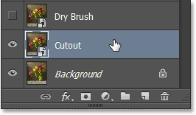

Selecting the Cutout layer.

## Step 7: Apply The Cutout Filter

We’re ready to apply the first of three filters we’ll be using to create the watercolor painting effect. As you may have guessed, the first filter is named **Cutout**, and we’re going to use it to simplify our image, removing much of the finer detail. In Photoshop CS6, this filter is found in the Filter Gallery, so go up to the **Filter** menu at the top of the screen and choose **Filter Gallery**:

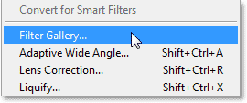

Going to Filter > Filter Gallery.

This opens Photoshop’s large Filter Gallery which is divided into three main columns – a large preview column on the left, the filter selection column in the middle, and the actual controls and options for the selected filter on the right. The filters in the middle column are organized into different categories. Select the **Artistic** category at the very top, then select the **Cutout** filter by clicking on its thumbnail:

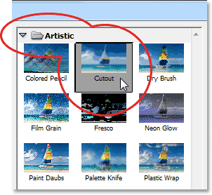

Choosing the Cutout filter from the Artistic category in the middle column.

Once you’ve selected the Cutout filter, the options for it will appear over on the right. Set both the

**Number of Levels** and **Edge Simplicity** options to **4**, then set the **Edge Fidelity** option to **2**:

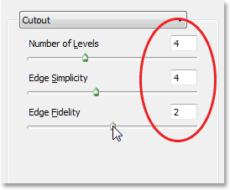

The Cutout filter options.

Click OK when you’re done to exit out of the Filter Gallery and apply the filter to the Cutout layer.

## Step 8: Change The Cutout Layer’s Blend Mode To Luminosity

Next, we need to change the layer’s [blend mode.](http://www.photoshopessentials.com/photo-editing/layer-blend-modes/intro/) You’ll find the **Blend Mode** option in the top left corner of the Layers panel (it’s the box that’s set to Normal by default). Click on the word “Normal” to open a list of other blend modes and choose **Luminosity** from the bottom of the list:

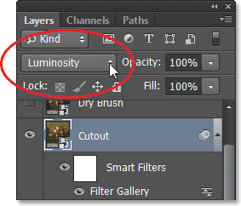

Changing the blend mode of Layer 1 to Luminosity.

Here’s what the effect looks like so far after applying the Cutout filter and changing the blend mode to Luminosity:

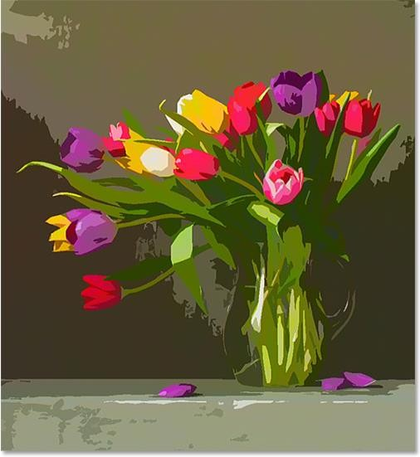

The first part of the effect is complete.

## Step 9: Select And Turn On The Dry Brush Layer

We’re finished with our Cutout layer, so let’s move on to the next one directly above it. Click on the **Dry Brush** layer in the Layers panel to select it, then click on its **layer visibility icon** to make the layer visible again in the document window:

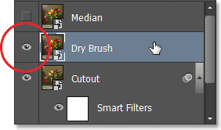

Selecting and turning on the Dry Brush layer.

## Step 10: Apply The Dry Brush Filter

We’re going to apply Photoshop’s **Dry Brush** filter to this layer which will add some texture to the image. In Photoshop CS6, the Dry Brush filter is also found in the Filter Gallery, so go back up to the **Filter** menu at the top of the screen and once again choose **Filter Gallery**. This time though, since the Filter Gallery was the last item we selected from the Filter menu, you’ll find it conveniently located right at the top of the list:

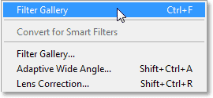

Photoshop displays the previously selected filter at the top of the Filter menu for easy access.

This re-opens the Filter Gallery set to the previously chosen filter, which in our case was Cutout. The **Dry Brush** filter is also located in the **Artistic** category in the middle column, and in fact is found directly to the right of the Cutout filter. Click on its thumbnail to select it. The options for the Dry Brush filter will then appear on the right. Set both the **Brush Size** and **Brush Detail** options to **10**, then set the **Texture** option to **3**. Click OK when you’re done to apply the filter and close out of the Filter Gallery:

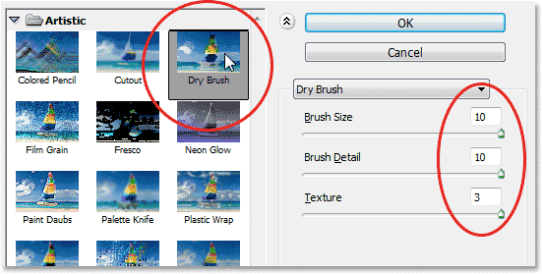

Selecting the Dry Brush filter and setting its options.

## Step 11: Change The Blend Mode Of The Dry Brush Layer To Screen

With the Dry Brush layer still selected, go up to the **Blend Mode** option in the top left corner of the Layers panel and change its blend mode from Normal to **Screen**:

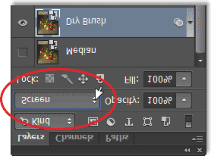

Changing the blend mode of the Dry Brush layer to Screen. Here’s my image with the second part of the effect now complete:

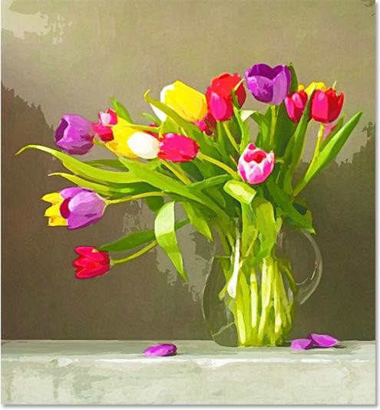

The image after applying the Dry Brush filter and changing the blend mode to Screen.

## Step 12: Select And Turn On The Median Layer

Two filters down, one more to go. Click on the **Median** layer in the Layers panel to select it, then click on its **visibility icon** to make the layer visible again in the document window:

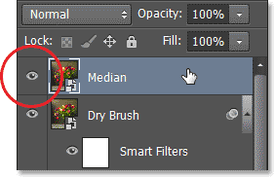

Selecting and turning on the Median layer.

## Step 13: Apply The Median Filter

The third filter we’ll use is **Median** which will remove even more image detail while keeping the edges of objects well defined. This one’s not part of the Filter Gallery. Instead, we access it by going up to the **Filter** menu, choosing **Noise**, and then choosing **Median**:

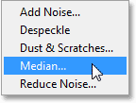

Going to Filter > Noise > Median.

This opens the Median filter dialog box. Set the **Radius** value down at the bottom of the dialog box to **12 pixels**, then click OK to apply the filter to the layer:

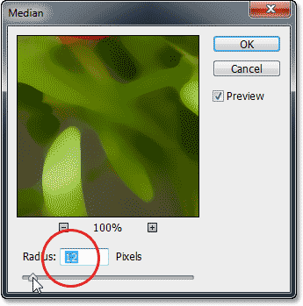

The Median filter dialog box.

## Step 14: Change The Blend Mode Of The Median Layer To Soft Light

Finally, with the Median layer still selected, change its **blend mode** from Normal to **Soft Light**:

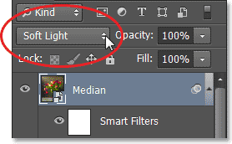

Changing the blend mode to Soft Light.

And with that, we’re done! Here’s the original image once again for comparison:

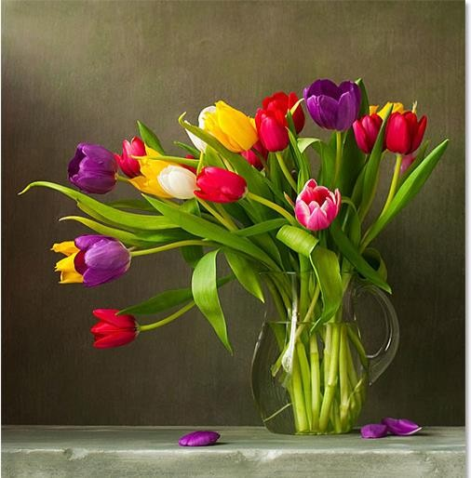

The original photo once again.

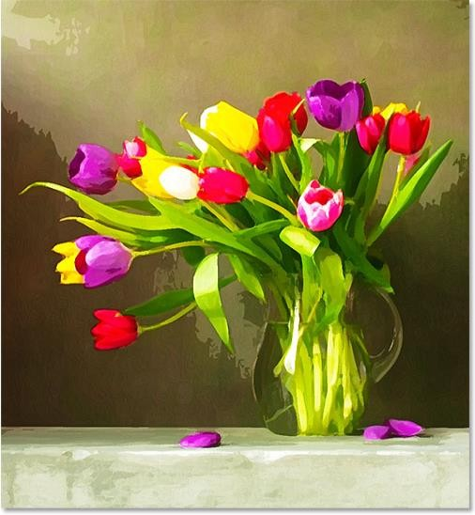And here, after applying the Median filter and changing the layer’s blend mode to Soft Light, is

The final watercolor painting effect:

The final watercolor painting result.

# 2.1) Photoshop CS6 New Features

## Background Save

If you’ve been using Photoshop for a while, you know that as we add more and more layers to a document, we increase the file size. You probably also know that the bigger the file size becomes, the longer it takes Photoshop to save your work. With Photoshop CS5 and earlier, saving a large file often meant taking a break, whether you wanted to or not, because Photoshop would essentially freeze as the file was being saved, locking you out of the program and preventing you from doing anything more until the saving process was completed. Thanks to the new Background Save feature in Photoshop CS6, that’s no longer the case.

Here’s an image that I currently have open in CS6:

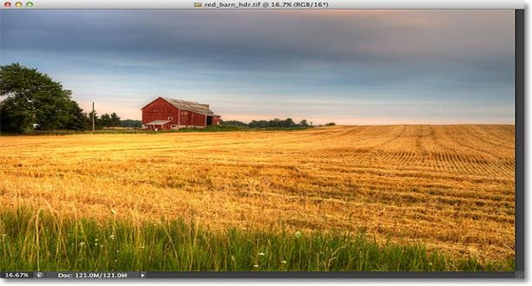

A newly opened image.

If we look in the bottom left of the document window, we see that the current file size is 121 MB, which is fairly small as far as Photoshop files go:

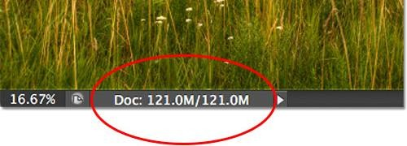

The file size is displayed in the bottom left of the document window.

If we look in my [Layers panel,](http://www.photoshopessentials.com/basics/layers/layers-panel/) we see that at the moment, my document contains only one layer, which is why the file size is relatively small:

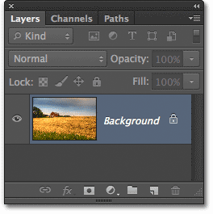

The Layers panel in Photoshop CS6.

With small file sizes like this, saving them isn’t a problem. The process happens so quickly that you barely notice it. Where the new Background Save feature in Photoshop CS6 begins to shine is when we start working with files that are hundreds of megabytes or more in size.

To see how it works, I’ll quickly increase the size of my file by making multiple copies of my image. To do that, I’ll press the keyboard shortcut **Ctrl+J** (Win) / **Command+J** (Mac) several times. Each time I press it, I make a new copy of the layer that the image is sitting on. Here we can see that my document now contains 8 layers – the original image on the Background layer, plus 7 copies above it:

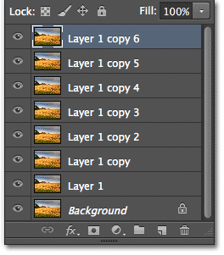

The document now contains 8 layers in total.

When we look again in the bottom left of the document window, we see that my file size has increased from 121 MB all the way up to 967.9 MB:

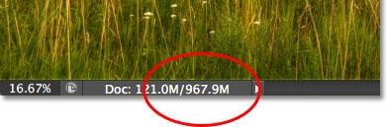

The file size is now much larger after making multiple copies of the image.

Saving a file as large as this will take some time, and as I mentioned, in Photoshop CS5 and earlier, we would essentially be locked out of Photoshop and unable to continue working until the saving process was finished. Watch what happens, though, as I save the file in Photoshop CS6, which I’ll do by going up to the **File** menu in the Menu Bar along the top of the screen and choosing **Save**:

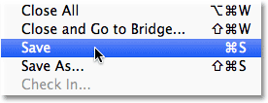

Going to File > Save.

The first clue that something is different with CS6 is that Photoshop now shows us how far along we are in the saving process by displaying a couple of **progress indicators**. The first one can be found in the name tab at the top of the document window, where the progress is displayed as a percentage. Here, Photoshop is telling me that the save process is 34% completed:

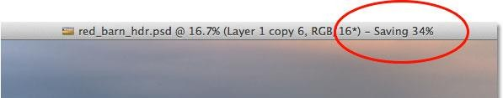

The first progress indicator appears in the name tab at the top of the document window.

The second indicator appears in the bottom left of the document window, and this one is a bit more helpful because along with the percentage value, it also displays the save process as a familiar blue progress bar:

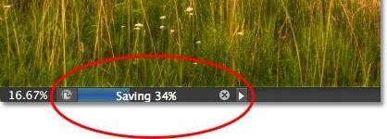

The save process is displayed as a percentage and as a progress bar in the bottom left of the document window.

While these progress indicators are a nice new addition to the interface, the real power of the Background Save feature in Photoshop CS6 is that, as its name implies, the saving process now takes place entirely in the background. What does that mean? It means that our workflow will no longer be interrupted when we go to save a large file because we won’t be locked out of Photoshop. We can continue working on the image even while it’s been saved!

As an example, here we can see that I’ve started working on a black and white conversion of my image (by adding a [Black and White adjustment layer](http://www.photoshopessentials.com/photo-editing/black-and-white-cs3/)) even though the progress indicators at the top and bottom of the document window are telling me that the save process is still only 51% completed. The Background Save feature will even let us switch to a completely different image to work on while the original image is being saved, something that was not possible in Photoshop CS5 and earlier:

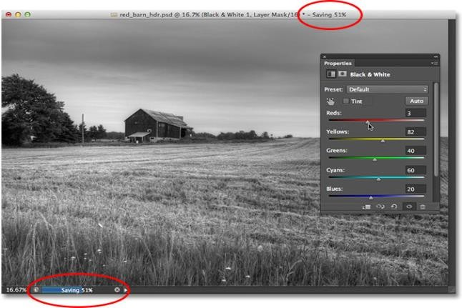

With Background Save, we can keep working while Photoshop is saving the file. We can even work on a different image while the first one is being saved.

## Auto Save

A second and even more impressive new feature in Photoshop CS6 is **Auto Save**. Even though Photoshop has evolved into a very mature and stable program, there’s always the chance that something will go wrong and Photoshop will crash. When that happens, we often end up losing all the work we’ve done on our image, forcing us to start over again from scratch. At least, that’s the way things *used* to be back in Photoshop CS5 and earlier.

Auto Save allows Photoshop to save a backup copy of our work at regular intervals so that if Photoshop does happen to crash, we can recover the file and continue from where we left off!

We can tell Photoshop how often we want it to save a backup copy of our work in the File Handling section of the Preferences. On a PC, go up to the **Edit** menu at the top of the screen, choose **Preferences**, and then choose **File Handling**. On a Mac, go up to the **Photoshop** menu, choose **Preferences**, then choose **File Handling**:

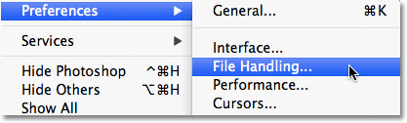

Go to Edit > Preferences > File Handling (Win) or Photoshop > Preferences > File Handling (Mac).

Here, you’ll find the **Automatically Save Recovery Information Every** option, which by default is set to 10 minutes, meaning that Photoshop will save a backup copy of your work every 10 minutes. You can increase it to every 5 minutes, as I’ve done here, or if you’re more of a gambler, you can set it to save a backup copy once every hour (there’s also a 15 minutes and 30 minutes option):

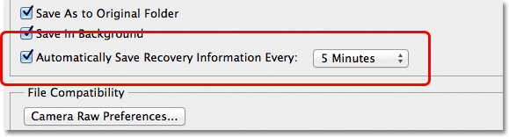

We can have Photoshop save our recovery information every 5, 10, 15 or 30 minutes, or once every hour.

It’s important to note that Photoshop isn’t saving over your original file (which would be very bad). The recovery information is kept in a separate backup file. If Photoshop does happen to crash while you’re working, simply re-open Photoshop and it will automatically open the most recently saved backup copy, complete with all the work you had done up to the point where Photoshop saved the backup copy (assuming, of course, that you had been working long enough for Photoshop to have made at least one backup copy). You’ll know it’s the backup copy because Photoshop adds **Recovered** to the file name (which is displayed in the tab at the top of the document window):

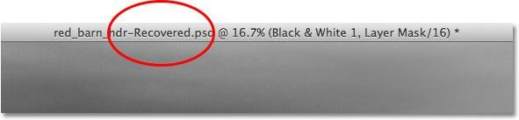

Photoshop adds “Recovered” to the name of the backup copy to distinguish it from the original.

And there we have it! That’s a quick look at the new Background Save and Auto Save features in the newly released Photoshop CS6!

# Photo Editing

## How To Lighten And Brighten Eyes In Photoshop Step 1: Add A Levels Adjustment Layer

Before we begin, let’s take a quick look in my [Layers panel](http://www.photoshopessentials.com/basics/layers/layers-panel/) so we can see that at the moment, all I have in my document is a single layer – the [Background layer](http://www.photoshopessentials.com/basics/layers/background-layer/) – which holds my original image:

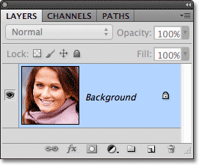

The Layers panel.

To brighten the woman’s eyes, the first thing we need to do is add a Levels adjustment layer above the image. Click on the **New Adjustment Layer** icon at the bottom of the Layers panel:

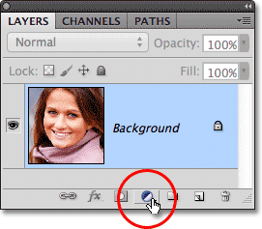

Clicking on the New Adjustment Layer icon.

Choose **Levels** from the list of adjustment layers that appears:

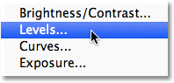

Choosing Levels from the list.

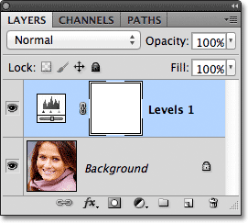We’re not actually going to do anything with the Levels adjustment layer. All we need to do is add it to the document, so if you’re using Photoshop CS3 or earlier, simply click OK in the top right corner of the Levels dialog box when it appears to close out of it. If you’re using Photoshop CS4 or higher, you won’t see a separate dialog box for the Levels command. Instead, the controls and options for the Levels adjustment layer appear in the new Adjustments panel so there’s no need to close out of it. Regardless of which version of Photoshop you’re using, when you’re done, you should see a Levels adjustment layer sitting directly above the Background layer in the Layers

panel:

The adjustment layer appears above the Background layer.

## Step 2: Change The Layer Blend Mode To Screen

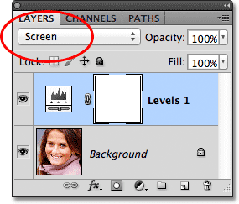Even though we’ve made no changes to any of the controls or options in the Levels adjustment layer, we can still use it to brighten the woman’s eyes simply by changing the adjustment layer’s **blend mode**. You’ll find the blend mode option in the top left corner of the Layers panel. By default, it’s set to Normal. Click on the word Normal, which opens a list of all the blend modes we can choose from, and select **Screen**:

Changing the blend mode of the adjustment layer from Normal to Screen.

I cover the Screen blend mode in much more detail in our [Five Essential Blend Modes For Photo](http://www.photoshopessentials.com/photo-editing/layer-blend-modes/) [Editing](http://www.photoshopessentials.com/photo-editing/layer-blend-modes/) tutorial, but in short, the Screen blend mode insta[ntly lightens the image. Of course, it’s](http://www.photoshopessentials.com/photo-editing/layer-blend-modes/) affecting the entire photo at the moment, not just the woman’s eyes, but we’ll that fix in a moment:

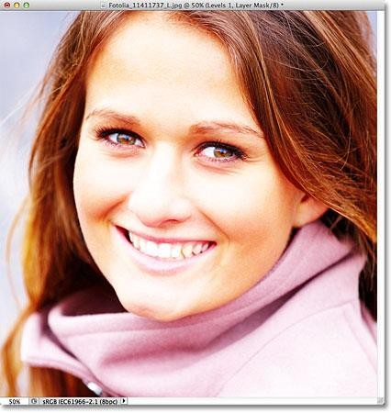

The Screen blend mode instantly lightens the entire image.

## Step 3: Fill The Layer Mask With Black

One of the many great things about adjustment layers in Photoshop is that each one automatically comes with its own [layer mask](http://www.photoshopessentials.com/basics/layers/layer-masks/) which we can use to control which areas of the image below it will be affected by the adjustment layer. We can see the **layer mask thumbnail** on the Levels adjustment layer in the Layers panel. By default, layer masks are filled with **white**, as we can see in the thumbnail, which means that the adjustment layer is currently affecting the entire image below it. This is why the whole image appears lighter:

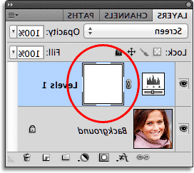

The layer mask on the adjustment layer is filled with white.

Let’s hide the effects of the adjustment layer so it’s not visibly affecting any part of the image, and we can do that by filling its layer mask with **black**. Go up to the **Edit** menu in the Menu Bar along the top of the screen and choose the **Fill** command:

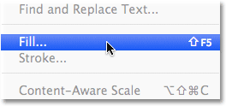

Go to Edit > Fill.

This opens Photoshop’s Fill dialog box. Change the **Use** option at the top of the dialog box to

**Black**, then click OK to close out of the dialog box:

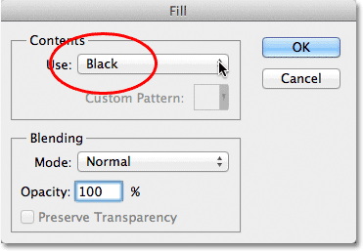

Changing the Use option to Black.

If we look again at the layer mask thumbnail in the Layers panel, we see that it’s now filled with black:

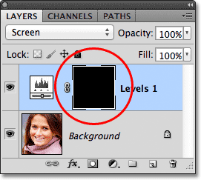

The layer mask for the adjustment layer is now filled with black.

With the mask filled with black, the effects of our Levels adjustment layer are now completely hidden and we’re back to seeing our original image in the document window. It’s important to note here that the adjustment layer is still brightening the image, just as we saw a moment ago. The only difference is that we can no longer see the brightening effect because it’s being hidden from view by the mask. We’re going to selectively bring back the lightening over the woman’s eyes in the next step:

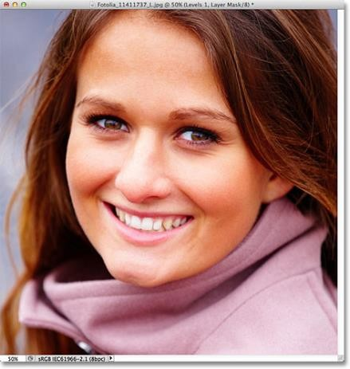

Back to the original photo.

## Step 4: Select The Brush Tool

Select the **Brush Tool** from the Tools panel:

Selecting the Brush Tool in Photoshop. Image © 2012 Photoshop Essentials.com

Grabbing the Brush Tool from the Tools panel.

## Step 5: Paint With White Inside The Eyes

To bring back the lightening effect inside the eyes, all we need to do is paint over them with our brush. We won’t actually be painting on the photo itself. Instead, we’ll be painting on the layer mask.

We’ll need to be painting with **white**, since white on a layer mask reveals the contents of the layer, which means we first need to make sure our brush color is set to white. Photoshop uses the current **Foreground color** as the brush color, so press the letter **D** on your keyboard to quickly reset your Foreground and Background colors to their defaults, which will instantly set the Foreground color to white. You can see the current Foreground and Background colors in the **color swatches** near the bottom of the Tools panel:

The Foreground and Background color swatches in the Tools panel. Image © 2012 Photoshop Essentials.com

Make sure the Foreground color (upper left swatch) is set to white.

Then, with your brush in hand and white as the brush color, simply paint inside the iris (the colored area in the center) of one of the eyes. You’ll want to use a fairly small brush for this, and the easiest way to adjust your brush size is from the keyboard. Pressing the **left bracket key** ( **[** ) will make the brush a little smaller each time you press it, while pressing the **right bracket key** ( **]** ) will make the brush a bit larger. As you paint over the iris, you’ll see the lightening effect from the adjustment layer being revealed. Here, I’m painting inside the eye on the left. Notice that it’s now appearing much lighter than the other eye which is still at its original brightness level:

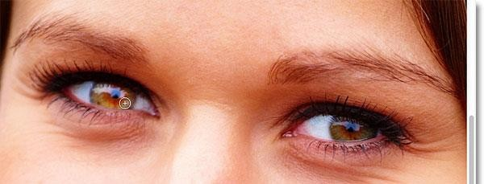

Painting inside the iris of the eye on the left of the photo.

If you make a mistake and accidently paint over an area you didn’t mean to (happens all the time), just press the letter **X** on your keyboard which will swap your Foreground and Background colors so that your Foreground color becomes **black**. Then paint over the mistake with black to hide the lightening effect. When you’re done, press the letter **X** again to set the Foreground color back to **white** and continue painting inside the eye.

Once you’ve lightened the first eye, do the same thing with the other eye, painting inside the iris with white to reveal the lightening effect. When you’re done, both eyes should appear brighter:

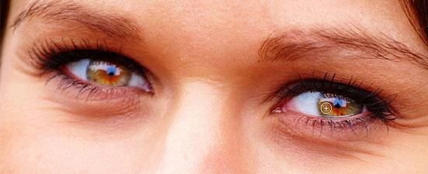

Painting with white inside the other eye.

## Step 6: Lower The Layer Opacity

If you find that the eyes now appear too bright, you can dial-down the brightness simply by lowering the opacity of the adjustment layer. You’ll find the **Opacity** option directly across from the blend mode option at the top of the Layers panel. By default, layer opacity is set to 100%. The lower we set it, the more the original photo below the adjustment layer will show through. I’m going to fine-tune my result by lowering the opacity down to around 65%:

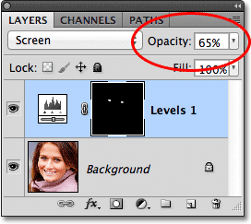

Lower the opacity of the adjustment layer to reduce the brightness in the eyes. And with that, we’re done! Here once again is the original untouched image:



The original photo.

And here’s the result after lightening the eyes:

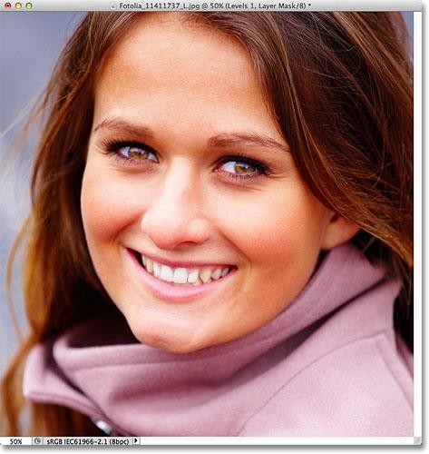

The final result.

## Changing Eye Color In An Image With Photoshop Solution.

**Step 1: Zoom In On The Eyes**

Before we begin, let’s make it easier to see what we’re doing by zooming in on the eyes in the photo. Select the [**Zoom Tool**](http://www.photoshopessentials.com/basics/photoshop-zoom/) from the Tools palette, or press the letter **Z** on your keyboard to select it with the shortcut:

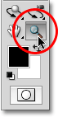

Select the Zoom Tool.

With the Zoom Tool selected, click and drag out a selection box around the eyes. This is the area we’ll be zooming in to:

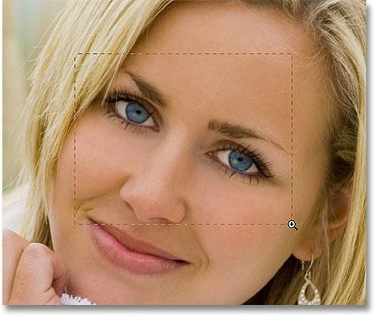

Drag out a selection box around the eyes.

Release your mouse button, and Photoshop fills the document window with the area you selected:

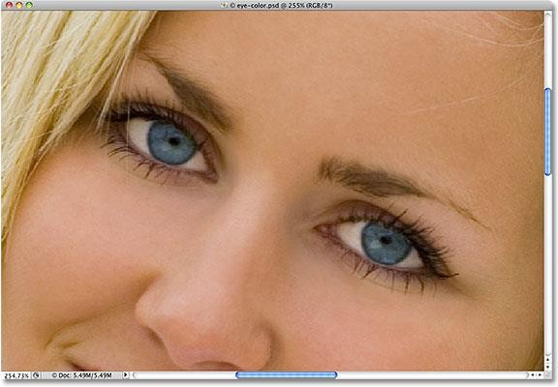

Photoshop zooms in on the selected area.

## Step 2: Select The Lasso Tool

Next, we need to select the eyes so we’re not affecting any other areas of the image. For that, we’ll use the [**Lasso Tool**](http://www.photoshopessentials.com/basics/selections/lasso-tool/). Select the Lasso Tool from the Tools palette, or press the letter **L** on your keyboard to quickly select it with the shortcut:

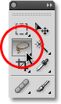

Select the Lasso Tool.

## Step 3: Draw Selections Around The Eyes

With the Lasso Tool selected, drag a selection around one of the eyes. Don’t worry if your selection outline isn’t perfect since we’ll clean things up later. Once you have the first eye selected, hold down your **Shift** key and draw a selection around the other eye. Holding down the Shift key will add the new selection to the previous one, allowing us to select both eyes at once:

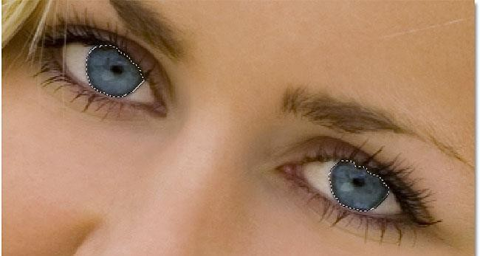

Select the first eye, then hold down Shift and select the other.

We don’t need the pupils in the center of the eyes selected, so let’s remove them from the selection. Hold down your **Alt** (Win) / **Option** (Mac) key and drag around each pupil with the Lasso Tool. This will remove them from the selection, leaving us with only the colored area selected. Again, don’t worry about being overly precise for now:

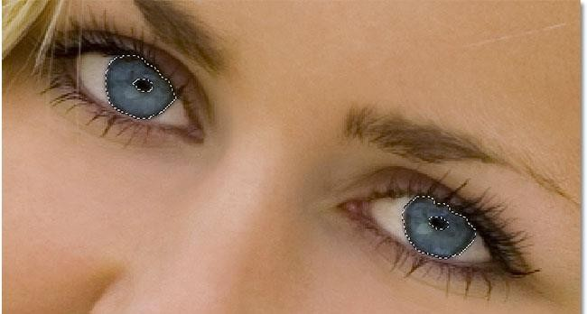

Hold down Alt (Win) / Option (Mac) and drag around the pupils to deselect them.

## Step 4: Add A Hue/Saturation Adjustment Layer

With the eyes now selected, we’re ready to change their color! For that, we’ll use a Hue/Saturation adjustment layer. Click on the **New Adjustment Layer** icon at the bottom of the Layers palette (it’s the circle split diagonally between black and white), then select **Hue/Saturation** from the list of adjustment layers that appears:

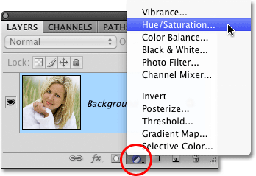

Click on the New Adjustment Layer icon and choose Hue/Saturation from the list.

## Step 5: Select The “Colorize” Option

If you’re using Photoshop CS4 as I am here, the options and controls for the Hue/Saturation dialog box will appear inside the **Adjustments Panel** which is new to CS4. In Photoshop CS3 and earlier, a Hue/Saturation dialog box will appear on your screen. Select the **Colorize** option by clicking inside its checkbox:

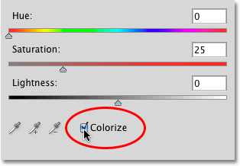

Select “Colorize”.

As soon as you select Colorize, you’ll see the eyes change color in the document window:

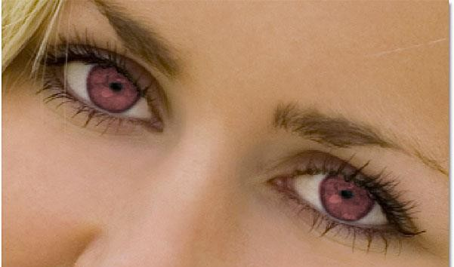

The eyes instantly change color.

## Step 6: Adjust The Hue, Saturation And Lightness

To change the color, simply adjust the **Hue**, **Saturation** and **Lightness** options by dragging their sliders left or right. Hue will change the basic color, Saturation changes the saturation of the color, and Lightness affects the overall brightness. Be careful not to drag the Saturation or Lightness sliders too far to the right, though, since things can quickly become unnatural looking. The image in the document window will continually update as you move the sliders so you can see a live preview of the changes:

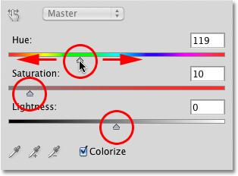

Dial in the color you want with the Hue, Saturation and Lightness sliders.

When you’re happy with the new color of the eyes, click OK to exit out of the Hue/Saturation dialog box (Photoshop CS4 users can leave the Adjustments Panel open since there’s no need to close it). Here’s my image after changing the woman’s eyes from blue to green:

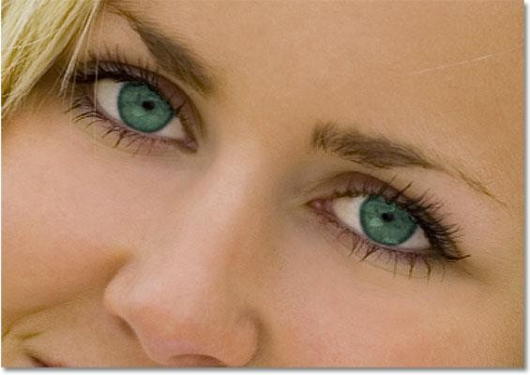

The Hue/Saturation adjustment makes it easy to select any color you want for the eyes.

## Step 7: Select The Brush Tool

If your initial selection of the eyes with the Lasso Tool wasn’t perfect, cleaning things up is as easy as painting with a brush! Select Photoshop’s **Brush Tool** from the Tools palette, or press the letter **B** to select it with the keyboard shortcut:

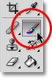

Select the Brush Tool.

## Step 8: Select The Hue/Saturation Layer Mask

If we look in our Layers palette, we see our Hue/Saturation adjustment layer sitting above the image on the Background layer. One of the great things about [**adjustment layers**](http://www.photoshopessentials.com/photo-editing/adjustment-layers/)is that they

include a built-in [**layer mask**,](http://www.photoshopessentials.com/basics/layers/layer-masks/) which makes it easy to control exactly which areas of the image are affected by the adjustment layer and which are not. All we need to do is paint on the layer mask with our brush, but first, we need to make sure the layer mask is selected. You should see a white highlight border around the layer mask’s thumbnail, which means the mask is selected. If you don’t see the highlight border, simply click directly on the thumbnail to select the mask:

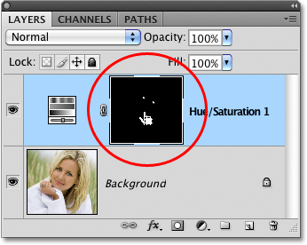

Make sure the layer mask for the adjustment layer is selected.

## Step 9: Paint On The Mask To Clean Up The Selection

To clean up the eyes, simply paint over any problem areas with your brush. Paint with white to add to the area that the Hue/Saturation adjustment layer is affecting, or with black to hide the effects of the adjustment layer. Photoshop paints using your current Foreground color, which you can see by looking at the **Foreground color swatch** near the bottom of the Tools palette:

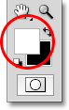

The Foreground color swatch shows the color you’re painting with.

With the layer mask selected, press the letter **D** on your keyboard to reset your Foreground color to white. To quickly switch to black, press the letter **X**, which swaps the Foreground and Background colors. Press **X** again to switch back to white.

To change the size of your brush, use the left and right bracket keys on your keyboard. Press the **left bracket key** ( **[** ) repeatedly to make the brush smaller or the **right bracket key** ( **]** ) to make it larger. Press **Shift+left bracket** to make the brush edges softer if needed, or **Shift+right bracket** to make them harder.

Here, I’m painting around the outer edge of one of the eyes with a small brush, with black as my Foreground color, to hide any areas where the new green color extended out into the white part of the eye:

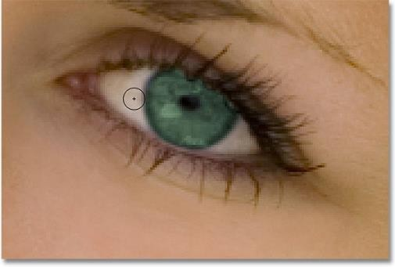

Painting with black on the layer mask to remove any unwanted green areas.

Here, after cleaning up the effect by painting on the layer mask, is my final result:

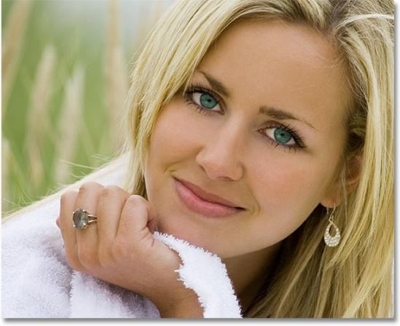

Her blue eyes are now green. No special contact lenses required.

## Photoshop Black and White Conversions – Desaturating

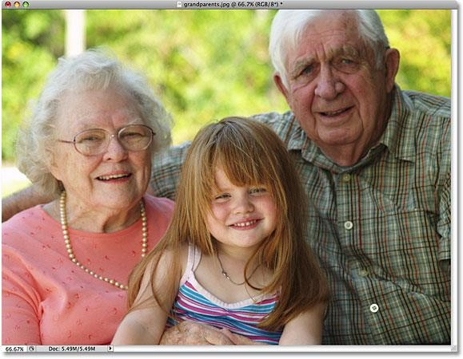

The original full color image.

## The Desaturate Command

The quickest way to desaturate the color in a photo is with Photoshop’s **Desaturate** command, which you’ll find by going up to the **Image** menu at the top of the screen, choosing **Adjustments**, and then choosing **Desaturate**:

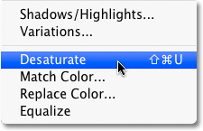

Go to Image > Adjustments > Desaturate.

For an even faster way to select the Desaturate command, simply press the keyboard shortcut **Shift+Ctrl+U** (Win) / **Shift+Command+U** (Mac). No matter which way you choose, Photoshop instantly desaturates all the color in the photo, leaving us with a basic black and white version:

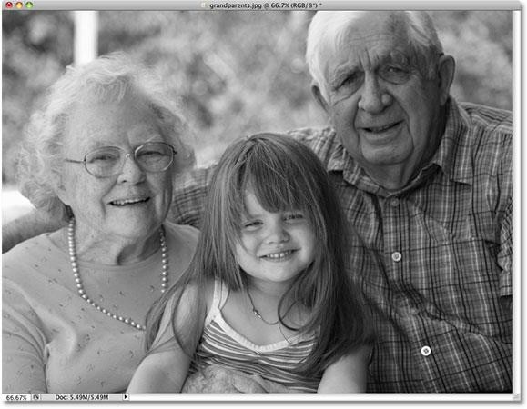

The photo now appears in black and white after desaturating the color.

Using the Desaturate command was certainly quick and painless, but the problem is, it’s also permanent. If we look in our **Layers palette**, we can see that our photo is sitting on the Background layer, and in the **layer preview thumbnail** to the left of the layer’s name, we see that sure enough, our image is now in black and white:

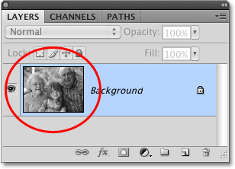

The preview thumbnail shows us a small preview of the contents of a layer.

Since we’ve made changes directly to the original image, if we save our document and close out of it at this point, the color in the photo will be gone for good. Even if we save the document as a Photoshop .PSD file, there will be no way to bring the original color back. Of course, one way we could have avoided this problem would have been by first duplicating the Background layer to create a copy of the image, then applying the Desaturate command to the copy. But there’s an even better way, one that gives us a little more creative freedom with the final result and, as we learned in our [**Reducing File Sizes With Adjustment Layers tutorial**,](http://www.photoshopessentials.com/photo-editing/photoshop-file-size/) will help keep the size of our Photoshop document to a minimum, and that’s by using a **Hue/Saturation adjustment layer**!

## The Hue/Saturation Adjustment Layer

In a later tutorial in this series, we’ll look at how we can use a Hue/Saturation adjustment layer to create more [**professional, custom black and white versions of color images**](http://www.photoshopessentials.com/photo-editing/black-and-white/hue-saturation/). Here, we’ll simply look at how we can use a Hue/Saturation adjustment layer to not only desaturate the color completely from an image but also how to keep just a hint of the original color for a more creative and interesting result.

First, before we go any further, let’s bring back the photo’s original color by undoing the Desaturate command, which we can do by going up to the **Edit** menu at the top of the screen and choosing **Undo Desaturate**. Or, a faster way to undo your last step is by pressing the keyboard shortcut **Ctrl+Z** (Win) / **Command+Z** (Mac) (to undo multiple steps, press **Ctrl+Alt+Z** (Win) / **Command+Option+Z** (Mac)):

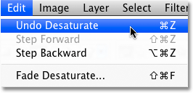

Go to Edit > Undo Desaturate, or press Ctrl+Z (Win) / Command+Z (Mac) to restore the color in the photo.

To add a Hue/Saturation adjustment layer, click on the **New Adjustment Layer** icon at the bottom of the Layers palette (it’s the circle split diagonally between black and white), then choose **Hue/Saturation** from the list of adjustment layers that appears:

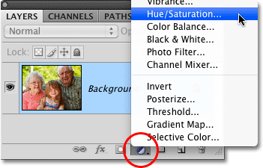

Click on the New Adjustment Layer icon and choose Hue/Saturation from the list.

If you’re using Photoshop CS4 as I am here, the controls and options for the Hue/Saturation adjustment layer will appear in the **Adjustments Panel** which is new to CS4. If you’re using Photoshop CS3 or earlier, the Hue/Saturation dialog box will appear on your screen.

To desaturate the color, simply drag the **Saturation** slider all the way to the left:

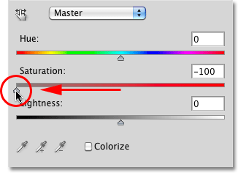

Drag the Saturation slider all the way to the left to completely remove the color from the image.

This gives us the exact same result that we saw with the Desaturate command. With the color removed, we’re left with a basic black and white version:

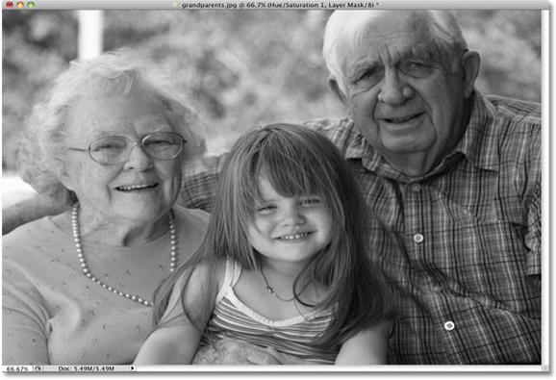

Once again, the color has been removed to give us a black and white version of the photo.

So what’s the difference between using the Desaturate command and dragging the Saturation slider? Well, let’s say we decide that we don’t want a completely black and white image. We’d like to bring back a subtle amount of the photo’s original color. With the Desaturate command, unless we duplicated the Background layer first and applied the command to a copy of the image, we’d be out of luck. But with the Hue/Saturation adjustment layer, bringing back some of the color is easy!

Since we’re using an adjustment layer, nothing we’re doing to our image is permanent. We’re free to make as many changes as we like without causing any harm to the original photo (see our [**Non-**](http://www.photoshopessentials.com/photo-editing/adjustment-layers/)[**Destructive Photo Editing With Adjustment Layers tutorial**](http://www.photoshopessentials.com/photo-editing/adjustment-layers/) to learn more). To restore some of the original color, simply drag the Saturation slider back a little towards the right. Keep an eye on your photo in the document window to judge the results as you drag the slider. The further you drag it towards the right, the more color you’ll restore. Since we want to bring back just a hint of color, I’m going to drag my Saturation slider a short ways toward the right until the value displayed in the Saturation input box is around -90, which brings back 10% of the original color saturation:

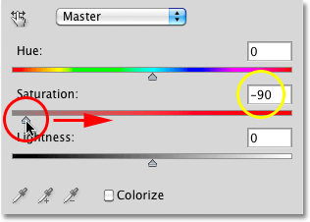

The Saturation slider makes it easy to control how much color is removed from the image. Rather than a completely black and white image, my photo now has more of a muted color effect:

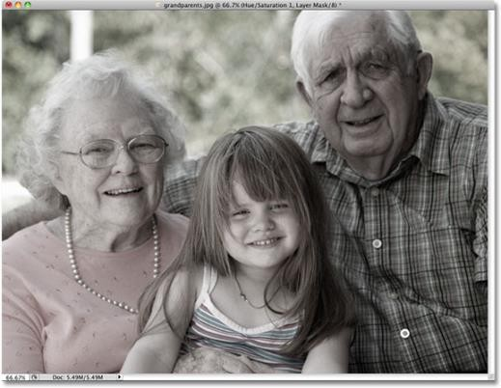Leaving a hint of color can sometimes be more interesting than a completely black and white effect.

If you’re using Photoshop CS3 or earlier, click OK in the top right corner of the Hue/Saturation dialog box when you’re done to exit out of it.

Since our black and white effect is entirely contained within the Hue/Saturation adjustment layer, if at any point we want to restore the original full color image, all we need to do is turn off the adjustment layer by clicking on its **layer visibility icon** (the “eyeball” icon), which you’ll find on the far left of the layer in the Layers palette:

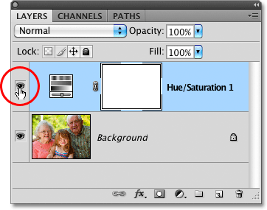

Turn the black and white effect on and off by clicking on the layer visibility icon. The original color is instantly restored:

With the adjustment layer turned off, the document window once again displays the original full color image

# Text Effect

## Multiple Text Strokes With Smart Objects In Photoshop Step 1: Add An Initial Stroke To The Text

Here’s the Photoshop document I’m starting with, made up of a single [Type layer](http://www.photoshopessentials.com/basics/type/) containing the

word “style” (since we’ll be using layer styles to add the strokes) in front of a black background:

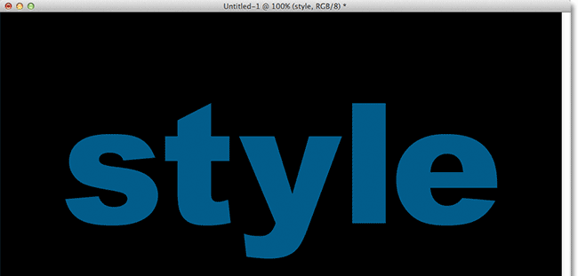

The original document.

If we look in my Layers panel, we see the Type layer above the Background layer. The Type layer is currently active (highlighted in blue):

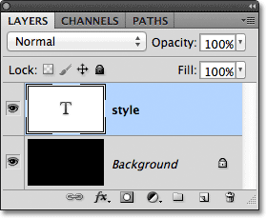

The Layers panel.

To add an initial stroke around the letters, I’ll click on the **Layer Effects** icon at the bottom of the Layers panel:

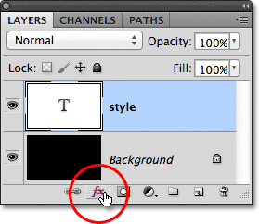

Clicking on the Layer Effects icon.

Then I’ll choose **Stroke** from the bottom of the list of layer effects that appears:

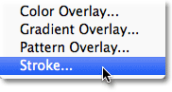

Choosing a Stroke layer effect.

This opens Photoshop’s Layer Style dialog box, with the options for the Stroke appearing in the middle column. First, I’ll choose a color for my stroke by clicking on the **color swatch** at the bottom of the options:

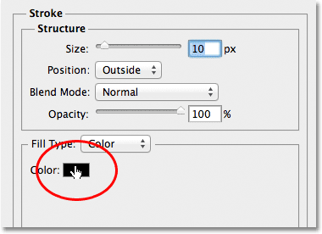

Clicking on the color swatch.

This opens Photoshop’s **Color Picker**. Since my text is a fairly dark shade of blue, I’ll choose a lighter shade of blue for the stroke. Of course, you can pick any color you need for your design:

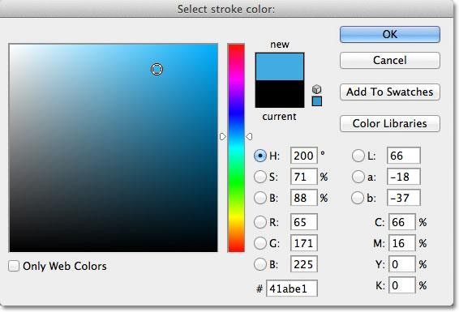

Choosing a light blue from the Color Picker.

With my color chosen, I’ll click OK to close out of the Color Picker. I want a thick stroke around the letters, so I’ll increase my stroke **Size** value to **21 px**:

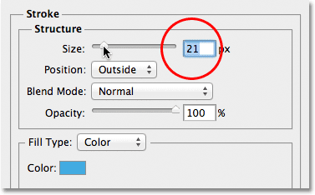

Increasing the stroke size to 21px.

When you’re happy with appearance of your stroke, click OK to close out of the Layer Style dialog box. Here’s what my text looks like with the initial stroke added:

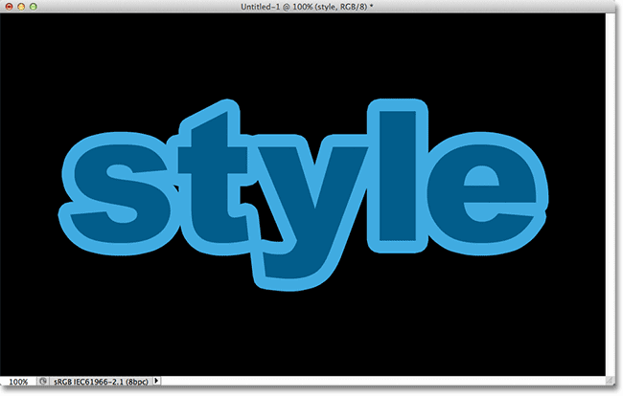

The first stroke appears around the text.

## Step 2: Convert The Type Layer Into A Smart Object

I now want to add a second stroke around the initial stroke, but that becomes an interesting problem. By default, Photoshop only allows us to add one Stroke effect at a time to a layer. If I was to click again on the Layer Effects icon at the bottom of the Layers panel and again choose Stroke from the list, Photoshop would re-open the Layer Style dialog box set to the Stroke options, but all I’d be able to do is edit the options for the stroke I just added, changing its color, size, or any of the other options, but I couldn’t add a second stroke.

At least, I couldn’t add a second stroke around the text itself. But what if we could somehow place the text inside a container, and then add a new stroke around the container? As it turns out, that’s exactly what we can do using Photoshop’s **Smart Objects**! A Smart Object is essentially a virtual container for the contents of a layer, and all we need to do is convert our Type layer into a Smart Object, at which point we can add a second stroke around the Smart Object!

To do that, click on the **menu icon** in the top right corner of the Layers panel. This will open a list of various options:

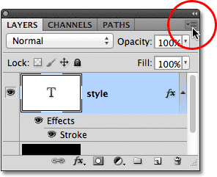

Clicking on the menu icon.

Choose **Convert to Smart Object** from the list of menu choices:

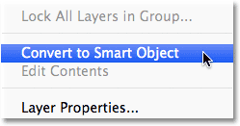

Choosing Convert to Smart Object.

Nothing will seem to have changed in the document window, but if we look in the Layers panel, we see that the Type layer has been converted into a Smart Object. A **Smart Object icon** is displayed in the lower right corner of the preview thumbnail:

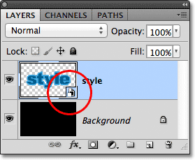

The Type layer is now a Smart Object.

## Step 3: Add A Stroke Around The Smart Object

With the text now inside a Smart Object, click on the **Layer Effects** icon at the bottom of the Layers panel and once again choose **Stroke** from the bottom of the list:

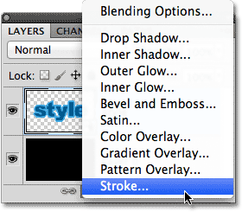

Choosing another Stroke layer effect, this time for the Smart Object.

Photoshop will again open the Layer Style dialog box set to the Stroke options. To change the stroke’s color, I’ll click on the **color swatch** as I did before and when the Color Picker appears, I’ll choose the same darker shade of blue as my text. I’ll leave the new stroke’s **Size** option set to the default value of **10px**, which will make the second stroke thinner than the initial one:

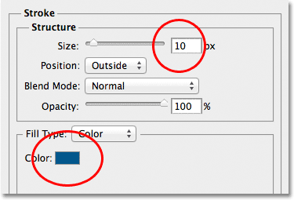

Setting the new stroke to the same color as the text, and leaving its size set to 10px.

When you’re done, click OK to close out of the Layer Style dialog box. If we look at my text in the document window, we see that the second stroke now appears around the initial one. Even though it looks like the new stroke is around the text, it’s actually around the Smart Object that’s holding the text:

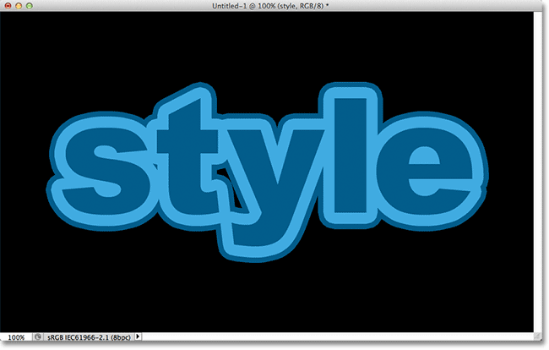

A second, darker blue stroke now appears around the initial stroke.

## Step 4: Repeat Steps 2 And 3 To Add More Strokes (Optional)

Photoshop allows us to nest Smart Objects inside other Smart Objects, which means we can use this technique to add even more strokes if we like! All we need to do is repeat Steps 2 and 3. First convert the current Smart Object into a new Smart Object by clicking on the **menu icon** in the top right corner of the Layers panel and choosing **Convert to Smart Object** from the list. This will place the current Smart Object inside a new one. Then, add a stroke around the new Smart Object by clicking on the **Layer Effects** icon at the bottom of the Layers panel and choosing **Stroke** from the list.

I’ll add a third stroke around my text, this time set to the same lighter shade of blue as the initial stroke. I’ll leave its Size set to the same default value of 10px:

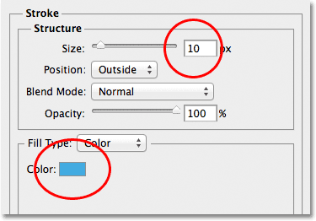

Adding a third stroke around the text (after creating another new Smart Object).

I’ll click OK to close out of the Layer Style dialog box, and I now have three strokes around my text! As we’ve learned though, it only *looks* like I have three strokes around the text. In reality, only the inner stroke is around the text itself. The middle stroke is around the Smart Object containing the text, and the outer stroke is around a new Smart Object containing the original Smart Object (which is containing the text):

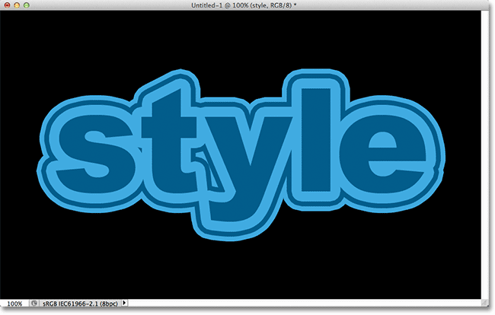

The final result

## Digital Photo Essentials

* 1. **Save Photos For Email or The Web In Photoshop CS5 Solution**

Here’s a photo I currently have open on my screen that I need to optimize for the web:

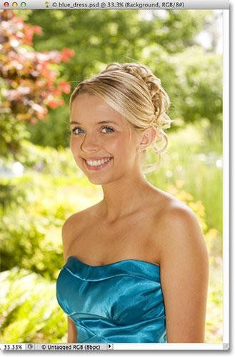

The original image.

If we look in my [Layers panel,](http://www.photoshopessentials.com/basics/layers/layers-panel/) we see that I’ve done a little bit of retouching work on this image, with a few [layers](http://www.photoshopessentials.com/basics/layers/) and adjustment layers added above the original image on the Background layer:

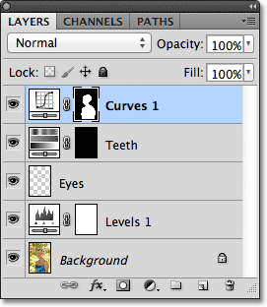

The Layers panel.

## Step 1: Duplicate The Image

To prepare this photo for emailing or uploading to a website, I’ll need to flatten the document down to a single layer and then resize the image to make it smaller, but I first want to make sure I

don’t lose any of the work I’ve done or make any permanent changes to the size of the original photo. To play it safe, before I do anything else, I’m going to make a duplicate copy of my image by going up to the **Image** menu in the Menu Bar along the top of the screen and choosing **Duplicate**:

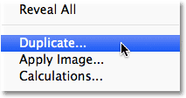

Go to Image > Duplicate.

Photoshop will pop open the Duplicate Image dialog box asking you to name the copy. You can just accept the default name that Photoshop has already entered (in my case, it’s “blue_dress copy”) because we can easily rename the image when we go to save it later. Click OK in the top right corner of the dialog box to accept the default name and close out of it:

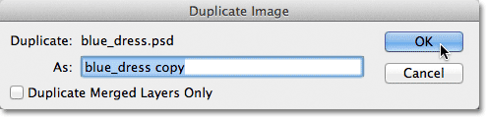

Click OK to accept the default name.

Photoshop will open an identical copy of the image, including any and all layers you added to the original version, in a separate document window:

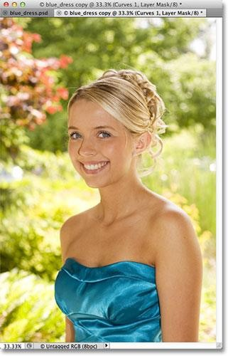

A copy of the original document appears in a new window.

## Step 2: Flatten The Image

Next, let’s flatten the copy of our image down to a single layer, which can help give us better results when we go to resize it, as we’ll be doing in a moment. Go up to the **Layer** menu at the top of the screen and choose **Flatten Image**:

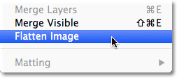

Go to Layer > Flatten Image.

If we look again in my Layers panel, we see that all of my layers have now been flattened down to a single Background layer:

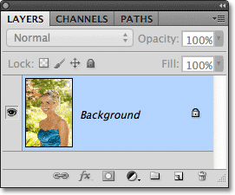

The Layers panel showing the flattened image.

## Step 3: Resize The Image

Now that our image has been flattened, let’s resize it to something more suitable for email or for displaying on a website. Go up to the **Image** menu at the top of the screen and choose **Image Size**:

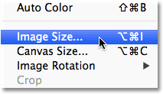

Go to Image > Image Size.

This opens the Image Size dialog box. As we’ll see shortly, Photoshop’s Save For Web & Devices dialog box also gives us the option to resize the image, but you’ll get better results if you resize your image beforehand using the Image Size command.

If we look at the top of the dialog box, in the **Pixel Dimensions** section, we see that my photo is currently 1571 pixels wide by 2356 pixels tall. That’s too big for most people to be able to fit the entire image on their screen if I was to email the photo to them, and it’s certainly too big to display on most websites:

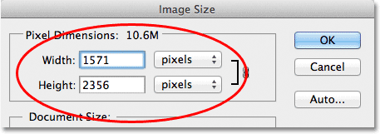

The current width and height, in pixels, of the image.

Generally speaking, for email and web viewing, you want to limit the dimensions of your photo to no larger than 800 pixels by 600 pixels, meaning that the width should not exceed 800 pixels and the height should not exceed 600 pixels. If you’re uploading the photo to a website, the website may have other, specific dimensions you need to stick to, but typically, keeping the size within 800 px by 600 px will allow most people to view the image on their screen comfortably.

Before you enter your new pixel dimensions, though, first make sure that all three options at the bottom of the dialog box – **Scale Styles**, **Constrain Proportions** and **Resample Image** – are all **checked**. Technically, with the image flattened, we don’t need to worry about the first option, Scale Styles, because we don’t have any layer styles applied to the image, but it’s easier just to make sure all three options are checked. Then, set the **Image Interpolation** option at the very bottom of the dialog box to **Bicubic Sharper (best for reduction).** It doesn’t say "Image Interpolation" anywhere but that’s what this bottom option is, and it controls how Photoshop handles the pixels during the resampling process. Setting it to Bicubic Sharper will give us the best results when downsizing an image for viewing onscreen:

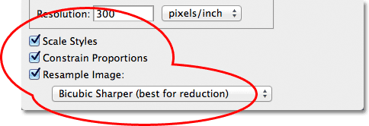

Make sure the first three options are checked and that the bottom option is set to Bicubic Sharper.

Then, go back up to the Pixel Dimensions section at the top of the dialog box and enter in your new dimensions. Since my photo is in portrait mode, meaning it’s taller than it is wide, and I don’t want the height to exceed 600 pixels, I’ll enter **600** pixels into the **Height** option. With the Constrain Proportions option selected at the bottom of the dialog box, Photoshop will

automatically enter a new width value for me to keep the width-to-height ratio of the image the same as it was originally. In my case, Photoshop entered **400** pixels for the **Width**:

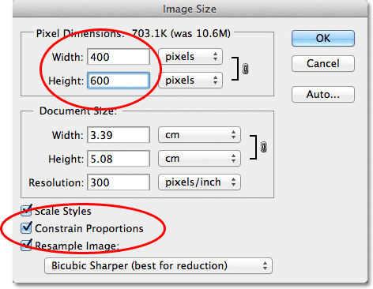

With Constrain Proportions selected, all we need to enter is a new width or height and Photoshop will enter the other one for us.

Notice that I made no changes to the **Resolution** value in the **Document Size** section of the dialog box. That’s because resolution determines [how large an image will print on paper](http://www.photoshopessentials.com/essentials/resizing-vs-resampling.php) and has nothing to do with viewing an image on a computer screen. All we need to focus on when resizing an image for display onscreen is the actual pixel dimensions of the image, found in the appropriately- named Pixel Dimensions section at the top of the dialog box.

Once you’ve entered your new dimensions, click OK in the top right corner of the dialog box to close out of it, at which point Photoshop will downsample the image to its new smaller size.

## Step 4: Save For Web

We’ve duplicated, flattened and resized our image. Now it’s time to optimize and save it. Go up to the **File** menu at the top of the screen and choose **Save For Web & Devices**:

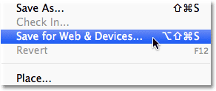

Go to File > Save For Web & Devices.

This opens Photoshop’s very large Save For Web & Devices dialog box, with a large **preview area** taking up most of the space. If you look just above the top left corner of the preview area, you’ll see a series of four tabs. By default, the **Optimized** tab is selected, which means you’re not seeing the original image. Instead, you’re seeing a live preview of what the image looks like with the current optimization settings applied (which we’ll look at in a moment):

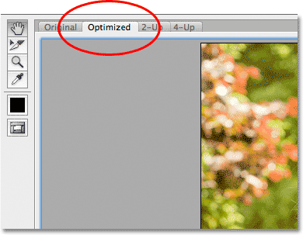

The preview area is set to the Optimized view mode by default.

You can leave the view mode set to Optimized, or, to view a side by side comparison of the original and optimized versions of the image, switch to the **2-Up** view mode by clicking on its tab:

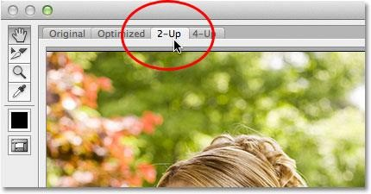

Switching to the 2-Up view mode.

With 2-Up selected, we can now see the original version of the image on the left and the optimized version on the right (if your image is in landscape mode, meaning it’s wider than it is tall, you’ll see a vertical preview with the original version on top and the optimized version below it):

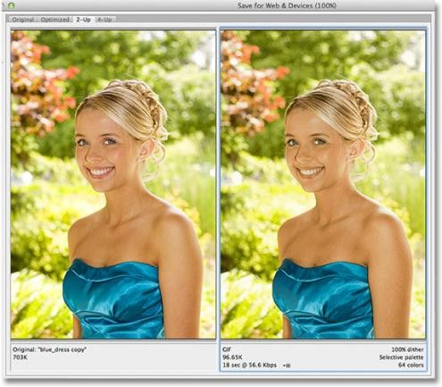

The original version is on the left, the optimized version on the right.

## File Format

On the right side of the dialog box are the various optimization options (if you’re not seeing any options listed, make sure you have the optimized version of the image selected in the preview

area). The first thing we need to do here is choose the correct [**file format**](http://www.photoshopessentials.com/essentials/file-formats/) for our image. If this is the first time you’re using the Save For Web & Devices dialog box, you’ll see the **GIF** file format chosen at the top (directly below the word “Preset”). GIF is a great format to use for saving web graphics, but for photos, we want to use the **JPEG** format, so change the option from GIF to JPEG if it isn’t set to JPEG already:

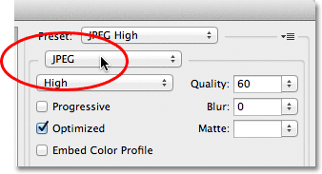

Set the file format to JPEG.

## Image Quality

Directly below the file format option are the **image quality** options. We can choose from a preset quality setting (Low, Medium, High, Very High, and Maximum) on the left or we can dial in a specific value into the **Quality** option on the right. While it may be tempting to choose the highest quality settings for our photos so everyone can see how truly awesome they are, optimizing them for email or the web means we need to keep the file size as small as possible, and that means finding a middle ground between image quality and file size. The **High** quality preset is almost always the best choice, giving us the best of both worlds – acceptable image quality and relatively small file sizes. Choosing the High preset will automatically set the Quality setting to **60**:

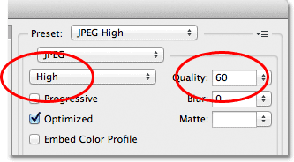

Choose the High quality preset, which sets the Quality value to 60.

Once you’ve chosen the quality setting, make sure the **Optimized** option is selected, which can help reduce the file size a little more. Leave the **Progressive** option unchecked, and leave **Embed Color Profile** unchecked as well, since most web browsers don’t support color profiles anyway:

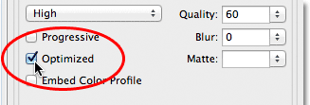

Choose Optimized, and leave Progressive and Embed Color Profile unchecked.

## Color Space

Finally, select the **Convert to sRGB** option if it isn’t checked already. This will make sure the photo is saved in the sRGB [color space,](http://www.photoshopessentials.com/basics/color-settings/) which, long story short, means the colors in your photo will display correctly on the web or when someone views the image in an email:

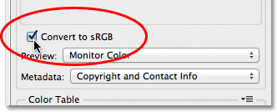

The Convert to RGB option keeps the colors in your photos from looking dull and drab on other people’s computer screens.

## Image Size

I mentioned earlier when we looked at how to resize the photo using the Image Size command that the Save For Web & Devices dialog box also gives us the option to resize the image. You’ll find the Image Size options in the bottom right corner of the dialog box. In my case here, the dialog box is showing that my photo is 400 pixels wide by 600 pixels tall since that’s what I resized it to earlier. While it may seem convenient to be able to resize the image while you’re setting all of the other web optimization options, you’ll get better resizing results if you ignore these options here and stick with the actual Image Size command:

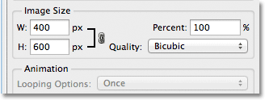

The Image Size options in the bottom right of the dialog box.

## File Size Comparison

At this point, we’ve done everything we need to do, but before we close out of the Save For Web

& Devices dialog box and actually save the image, let’s take a quick look below the two versions of the photo in the preview area to compare the file size of the original version with the size of the optimized version. In my case, the original photo (on the left) was a whopping **703 Kb**, much too large for the web, especially for people with slower internet speeds, while the optimized version (on the right), which looks almost as good as the original, is only **58.41 Kb**:

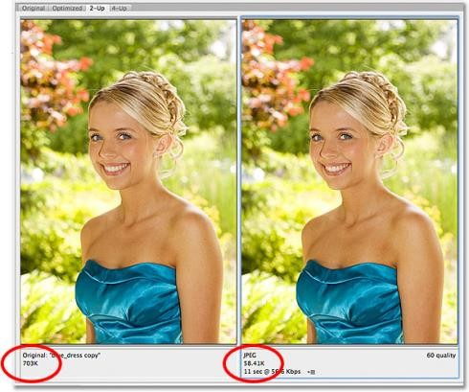

The 2-Up view lets us compare file sizes between the original and optimized versions of the image.

## Step 5: Save The Image

To save the optimized version of your photo, click the **Save** button at the bottom of the dialog box. Photoshop will pop open the **Save Optimized As** dialog box, which lets you rename the image if you need to, as well as navigate to the directory on your hard drive where you want to save it. I’m going to rename my photo “blue-dress.jpg” and I’ll save it to a “web photos” folder on my desktop. When you’re done, click **Save** to save the image and close out of the dialog box:

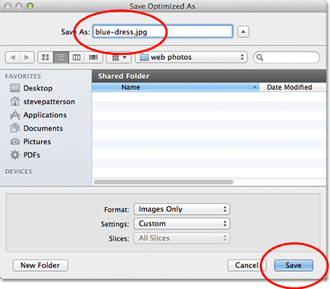

The Save Optimized As dialog box.

And there we have it! The photo is now resized and fully optimized, ready to be emailed to friends and family members or uploaded to the web, thanks to the Image Size and Save For Web & Devices commands in Photoshop CS5!